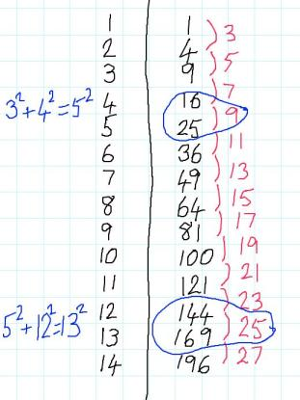
Charlie has been investigating square numbers. He decided to organise his work in a table:

Charlie noticed some special relationships between certain square numbers:
${3^{2}+4^{2}=5^{2}}^{}$ $5^{2}+12^{2}=13^{2}$

Sets of integers like 3, 4, 5 and 5, 12, 13 are called Pythagorean Triples, because they could be the lengths of the sides of a right-angled triangle.

He wondered whether he could find any more...

Can you extend Charlie's table to find any more sets of Pythagorean Triples where the hypotenuse is 1 unit longer than one of the other sides?
Do you notice any patterns?
Can you make any predictions?

Can you find a formula that generates Pythagorean Triples like Charlie's?
Can you prove that your formula works?

Alison has been working on Pythagorean Triples where the hypotenuse is 2 units longer than one of the other sides.
So far, she has found these:
$4^{2}+3^{2}=5^{2}$ $6^{2}+8^{2}=10^{2}$ $8^{2}+15^{2}=17^{2}$
Some of these are just scaled-up versions of Charlie's triples, but some of them are new and can't be divided by a common factor (these are called primitive triples).

Can you find more Pythagorean Triples like Alison's?

Can you find a formula for generating Pythagorean Triples like Alison's?
Can you prove that your formula works?

